**ME 111 Engineering Drawing**

**Section of solids Thursday Batch**

**Q.1** A cone with base 75 mm diameter and axis 80 mm long is resting on its base on H.P. It is cut by a section plane perpendicular to the V.P., inclined at 45º to the H.P. and cutting the axis at a point 35 mm from the apex. Draw the front view, sectional top view, sectional side view and true shape of the section. [20 marks]

{Note: Please don’t cut the marks if the student divides the base circle into 6 or 8 equal number of parts. Dividing the circle into 4 equal parts is not to be accepted as 4 points are not sufficient to give the proper views of sections.}

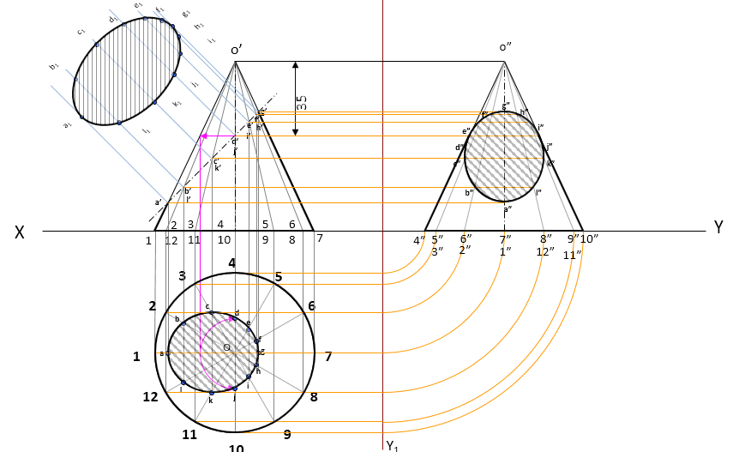

**Q.2** A pentagonal prism is resting on its one of the edges of base on HP while its axis is making 60° with HP. The edge on which the solid is resting, makes 90° with the reference line. The solid in this position, is cut by a section plane whose VT makes 60° with HP and is passing thru the farthest corner point of the solid from HP. Draw the front view, sectional top view and true shape of the section. [30 marks]



